**1. Business Architecture for Speech to Text Converter**

**1.1. Introduction**

The Speech to Text Converter is designed to provide users with a robust solution for converting spoken language into written text. The application leverages advanced speech recognition technologies to ensure high accuracy and real-time transcription. This business architecture document outlines the current process, different personas using the system, business problems addressed, and how the new system improves the existing process.

**1.2. Business Need of the Project**

Current Process: The current process of transcribing spoken words into text is predominantly manual or reliant on less sophisticated automatic tools. Users typically record audio using a separate device or application, and then manually transcribe the content or use basic transcription services that may lack accuracy, real-time capabilities, and multi-language support. This process is time-consuming, prone to errors, and lacks the efficiency needed for quick and accurate transcription.

**Personas and Their Needs:**

**1. General Users:**

• Need: Accurate and quick transcription of spoken words into text for various purposes such as note-taking, documentation, and content creation.

• Current Process: Manual transcription or use of basic transcription tools, which are often inaccurate and inefficient.

**2. Developers:**

• Need: Integration of reliable transcription services into their applications to enhance functionality and user experience.

• Current Process: Limited by the capabilities of existing APIs and services, which may not provide high accuracy or customization options.

**3. Professionals (e.g., journalists, researchers):**

• Need: Efficient and reliable transcription services to quickly convert interviews, meetings, and lectures into text.

• Current Process: Relying on manual transcription services or hiring transcribers, which is costly and time-consuming.

**4. Users with Disabilities:**

• Need: Accessible transcription services with features that assist users with visual impairments.

• Current Process: Manual transcription with limited accessibility features, making it challenging for visually impaired users to transcribe audio content.

**Business Problems:**

**1. Inefficiency:**

• Manual transcription is time-consuming and resource-intensive.

• Existing automatic transcription tools lack accuracy and real-time capabilities, leading to inefficiency in workflows.

**2. Inaccuracy:**

• Basic transcription tools often misinterpret speech, especially with accents, multiple languages, or background noise, resulting in incorrect transcriptions.

**3. Limited Accessibility:**

• Current transcription processes do not adequately cater to users with disabilities, particularly those with visual impairments.

**4. Data Security:**

• There is a risk of data breaches and privacy issues with manual and less secure transcription services.

Business Solutions Provided by the Application

**Improved Efficiency:**

• The application automates the transcription process, providing real-time transcription that significantly reduces the time and effort required to convert speech into text.

• Users can transcribe audio content on-the-go without the need for manual intervention, streamlining their workflows.

**Enhanced Accuracy:**

• By integrating advanced speech recognition engines and providing customizable language models, the application ensures high transcription accuracy across different languages and accents.

• Real-time feedback and editing capabilities allow users to correct any inaccuracies immediately, improving overall transcription quality.

**Accessibility Features:**

• The application includes features such as audio feedback and text highlighting, making it accessible to users with visual impairments.

• Compatibility with screen readers and other assistive technologies ensures that all users can effectively use the application.

**Data Security:**

• The application implements robust security measures, including data encryption and compliance with data protection regulations, ensuring that user data is handled securely and privately.

• Secure authentication and role-based access control further enhance data security.

**1.3. Business Architecture Diagram**

A business architecture diagram provides a high-level view of the system's components and their interactions. Below is an outline of the key components and their roles:

**1. User Interface (UI):**

• Function: Provides the front-end interface for users to interact with the application, including recording audio, viewing transcriptions, and adjusting settings.

• Components: Input fields, real-time transcription display, settings menu.

**2. Speech Recognition Engine:**

• Function: Processes audio input and converts it into text using advanced speech recognition algorithms.

• Components: Language models, audio processing algorithms, real-time transcription module.

**3. Data Storage:**

• Function: Stores user data securely, including audio recordings, transcriptions, and user preferences.

• Components: Database management system (DBMS), encryption modules.

**4. Accessibility Features:**

• Function: Provides additional features to assist users with disabilities.

• Components: Audio feedback module, text highlighting, screen reader compatibility.

**5. Security and Compliance:**

• Function: Ensures that user data is protected and the application complies with relevant regulations.

• Components: Authentication system, encryption, compliance monitoring.

**6. Integration API:**

• Function: Allows the application to integrate with third-party applications and services.

• Components: API endpoints, data exchange protocols.

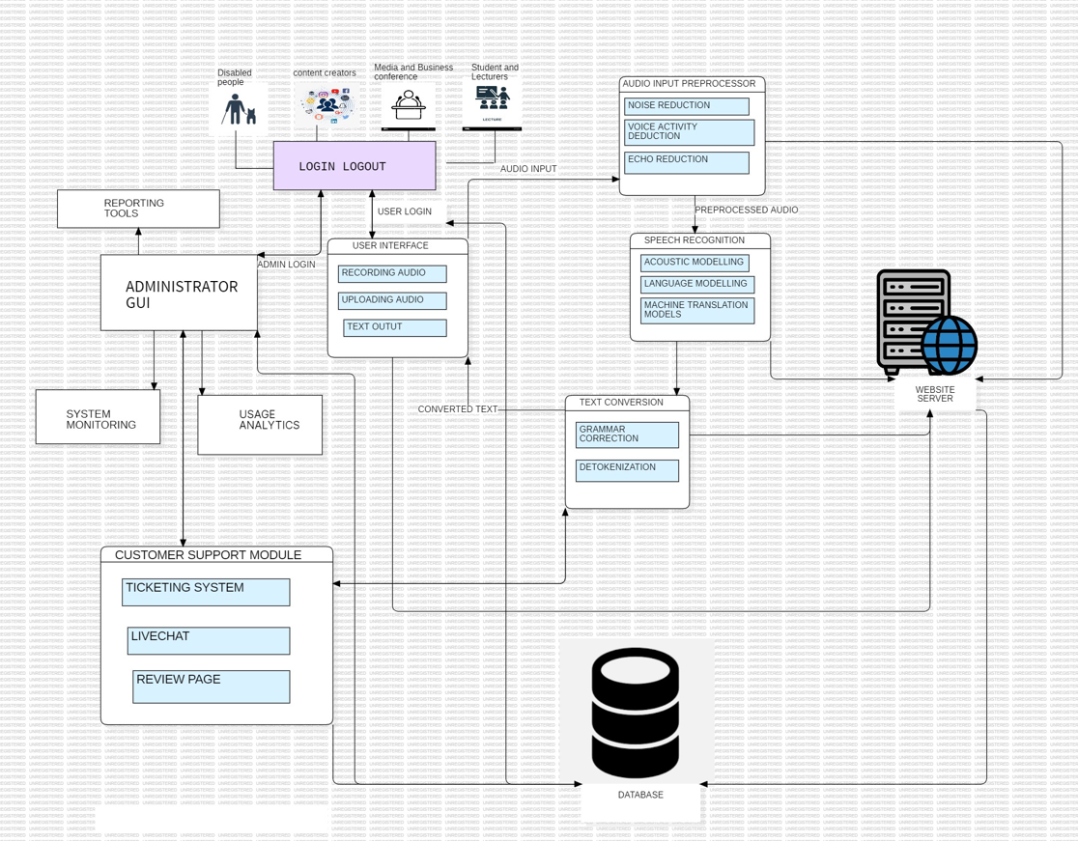

**1.4. Conclusion**

The Speech to Text Converter addresses significant business problems by automating and enhancing the transcription process. It provides high accuracy, real-time transcription, multi-language support, accessibility features, and secure data handling. By implementing this application, users from various backgrounds and needs can achieve efficient, accurate, and secure transcription of spoken language into text, thereby improving productivity and user satisfaction.